**CSE541 Computer Vision**

**Prof. Mehul Raval**

**Gaze Tracking**

**Week 1 Report**

| **Name** | **Enrolment Number** |
| --- | --- |
| Nityam Dixit | AU2040140 |
| Devyash Shah | AU2040152 |
| Kavan Gondalia | AU2040030 |
| Kush Patel | AU2040137 |

1. Learning opencv object detection

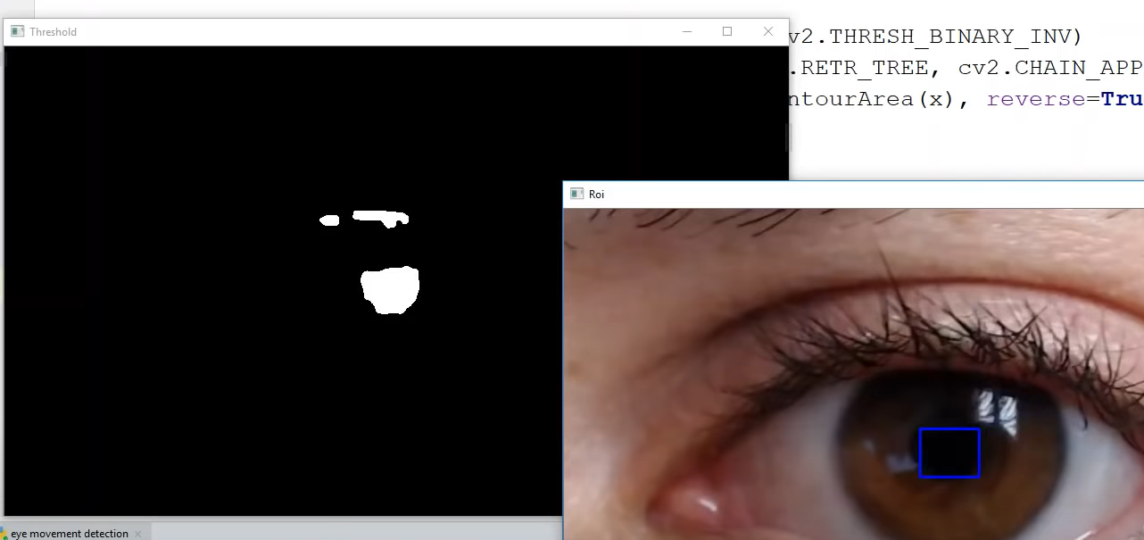

1. Installing YOLO and trying to build a custom model

We are trying different trackers and detectors for our use. We still don’t have a proper set-up for the camera. Because of that, we are testing it on the available stock videos.

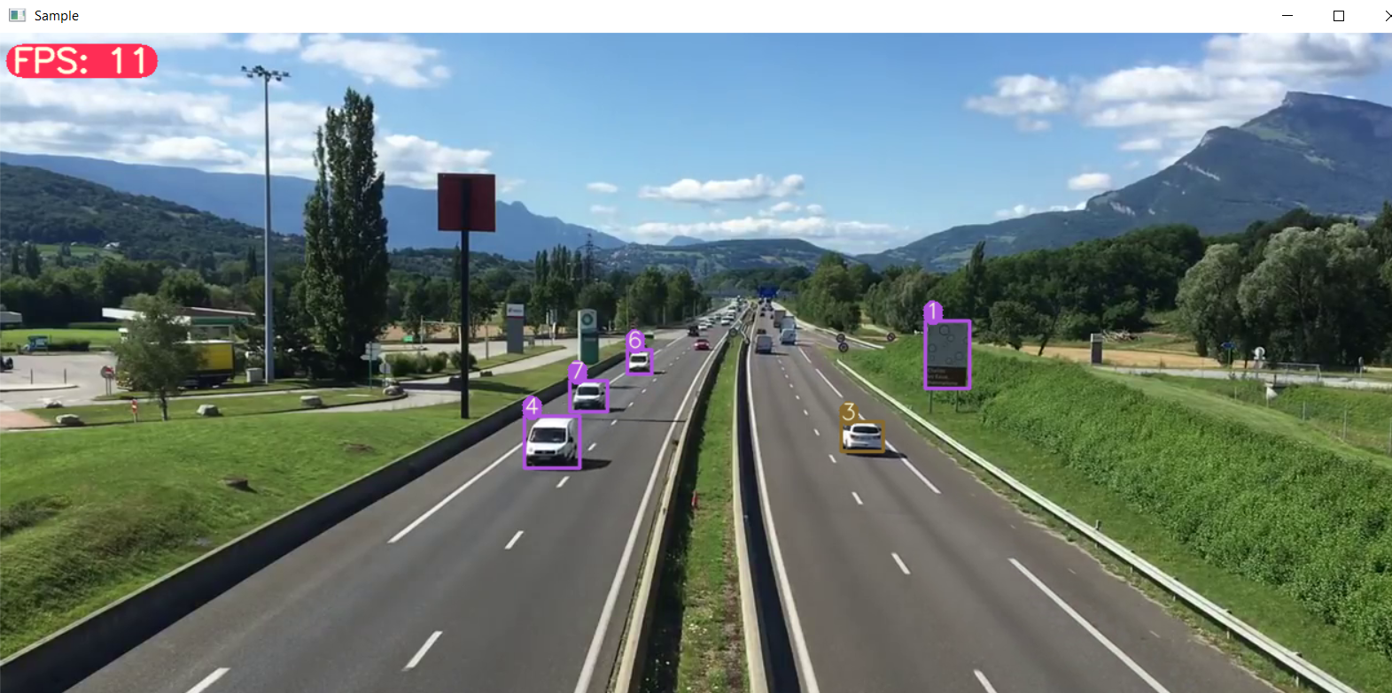

1. Arranging proper camera modules for the real world and eye tracking.

For the project, we need a 2-camera set-up. One of which is an IR camera.

Referring to this: [How to Convert a Webcam to a Near-Infrared Camera](https://youtu.be/ihuHuC12328)

The primary concern is conventional webcams are not suitable for low-distance focusing.

Referred sources:

[Gaze Tracking and Estimation](https://youtu.be/-lmc2-podgQ)

[Theory, Practice, and Standardization of Eye-tracking Technology](https://youtu.be/wi19uS4JFJ4)

<https://webgazer.cs.brown.edu/>